**Phase – II**

**Practice Project – I**

**Retrieving the Product Details Using the Product ID.**

**Sai Krishna Rajagopal**

**22-03-2022**

**GITHUB Repository URL:** [**https://github.com/SaiKrishna6699/JavaFSDTraining.git**](https://github.com/SaiKrishna6699/JavaFSDTraining.git)

**Technical Summary:**

1. **HTML, CSS**
2. **Java EE**
3. **Eclipse**
4. **Web Browser (Chrome)**
5. **MySQL**
6. **Tomcat 8.5**
7. **Git**
8. **HTML, CSS:**

A html page named Index.html with minimal CSS is created, which consists of a HTML Form takes input for the login.

1. **Java EE:**

The validation of USER Login was developed in Java Enterprise Edition (Java EE) using the concept of Servlets.

The Application is fully Functional and Working Perfectly with No Exceptions.

Short Summary of Code:

* In this Application there are one Java Servlets for full functional working of the application.
* Product Details is the Java Servlet Programs created for Get Details.
* DbConnection is a java class created to connect with Database.
* Product Details:
  + In the Login Servlet, It works on the response from the Index HTML page. The doGet method is used to request and take response from the HTML Page using Http Servlet package.
  + Database connection is imported form DbConnection java class using inheritance concept.
  + String Name and int Pid and Price are created to store the parameters from the HTML page for Product id, Name, Price.
  + Later the User Input will be verified to check whether the Product details are valid.
  + If it is valid then the session gets redirected to Dashboard servlet.
  + Else if not valid it will generate an error message in the Index html page.
* DbConnection:
  + In the DbConnection Java Class, The databases connection is configured using MySQL commands.
  + In the Db Connection Database details, Port Number, User name and Password will be given using JDBC connect

1. **Eclipse:**

Eclipse is the IDE used to Write the code. It is a very programmer friendly and easy to use application.

1. **Tomcat 8.5:**

Apache Tomcat is a webserver which is used to host web apps locally in the system. In this project Tomcat 8.5 is used to host the Servlet application. Tomcat 8.5 supports Java 7 and other latest versions of the Java EE.

1. **MySql:**

MySQL is an open-source relational database management system. It is structured query language created Oracle Corporation. Here MySql is used to connect database to eclipse using mysqlConnector jar file.

1. **Git & GitHub:**
   1. Git is the version control system used to store the data in a remote Repository.
   2. GitHub is the remote data base contains repository which is used to store the data.

Git Commands used:

$git init

$git remote -v

$git add .

$git commit -m “Adding PP1”

$git branch -M master

$git push -u origin master

1. Screenshots:

Output:

Index:

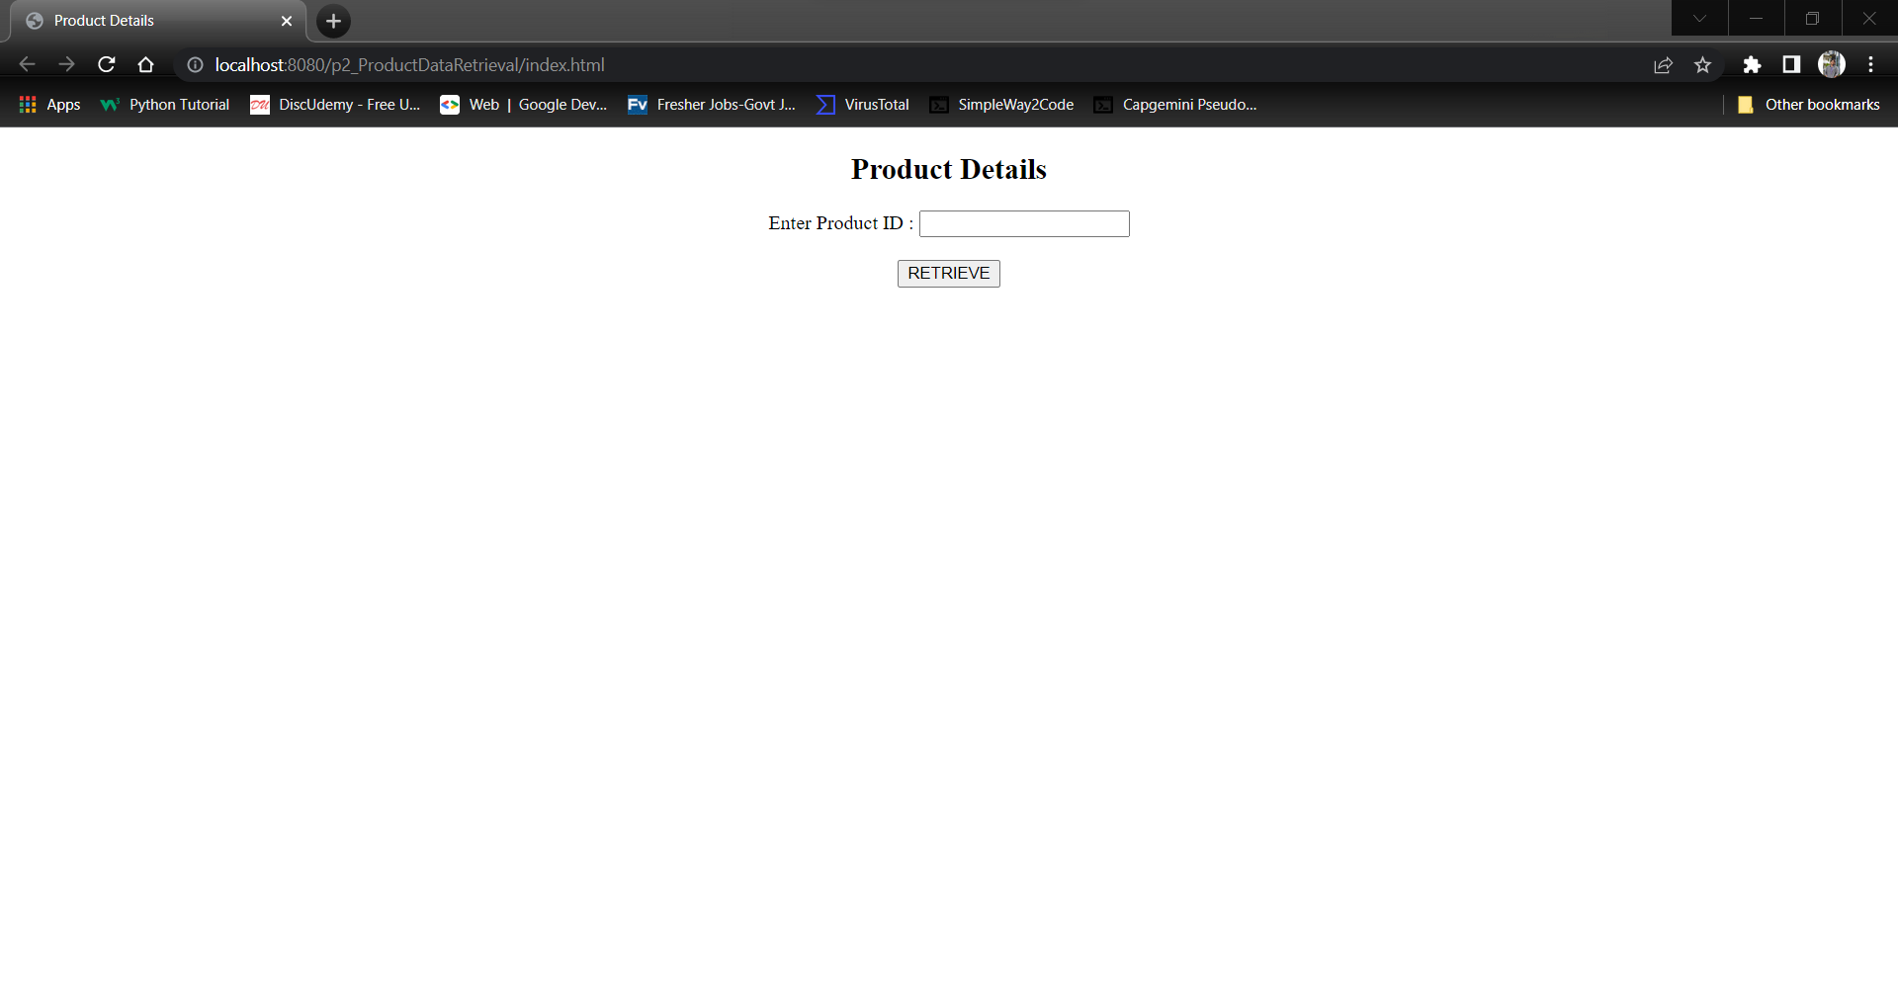

Output1:

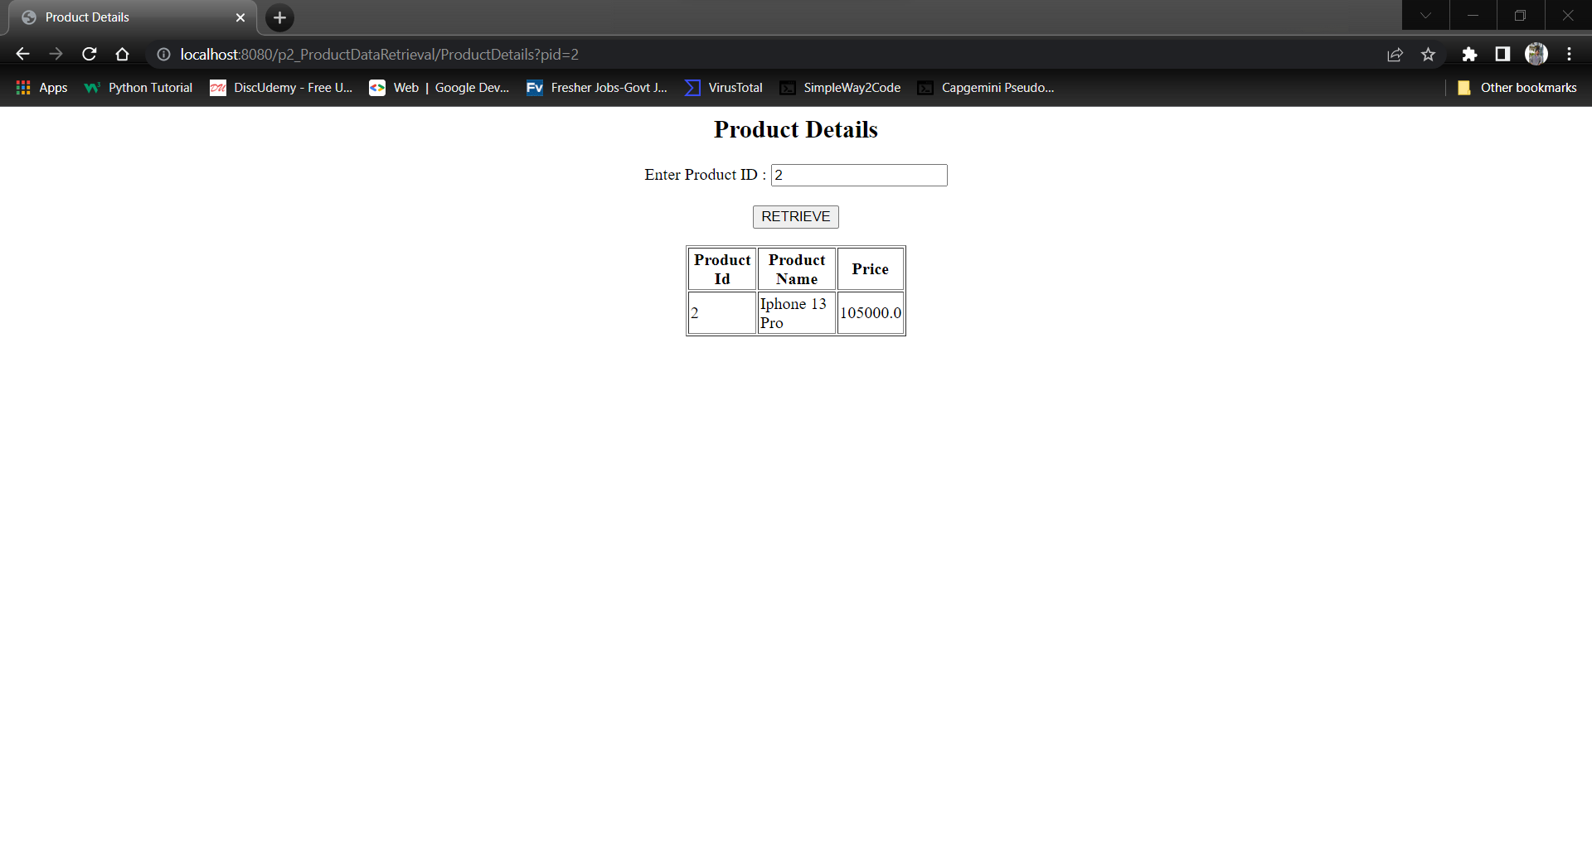

Output 2:

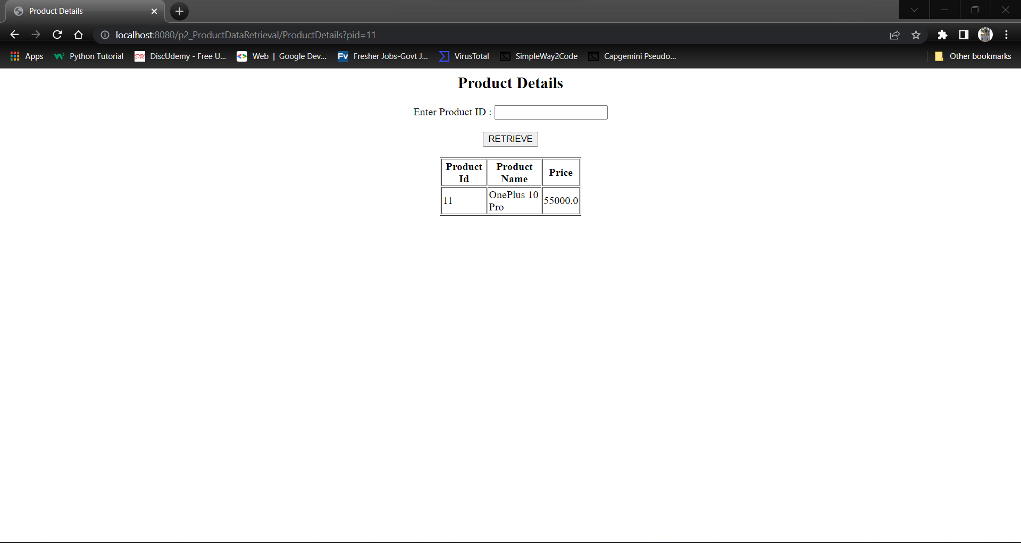

Git: